Assignment Module: 16

- View running processes with ps.
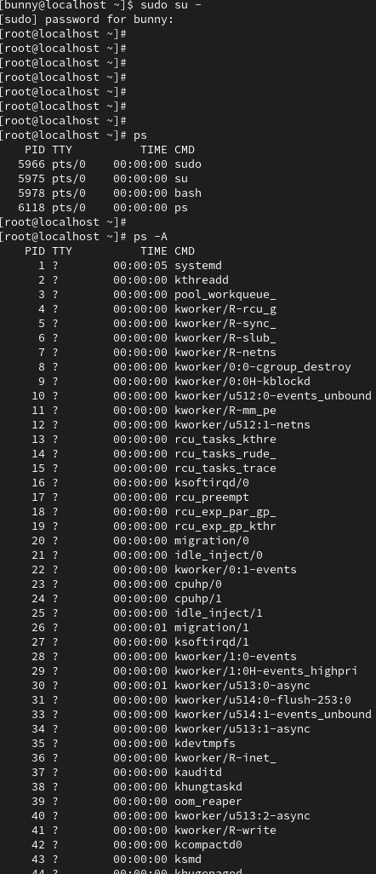
Answer:

- sudo su – (to access the root user)
- ps displays information about a selection of the active processes.
- When you write ps in cli it only shows the only process identifier (PID)
- When you write ps -A in cli it shows all the process identifier with time and the CMD.
- When you write ps -e in cli it shows the filter process identifier with time and the CMD.

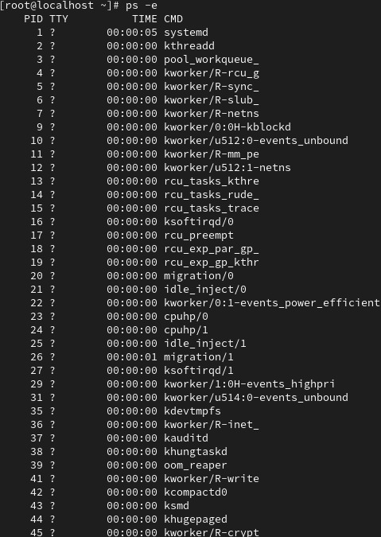

- Terminate processes with kill.
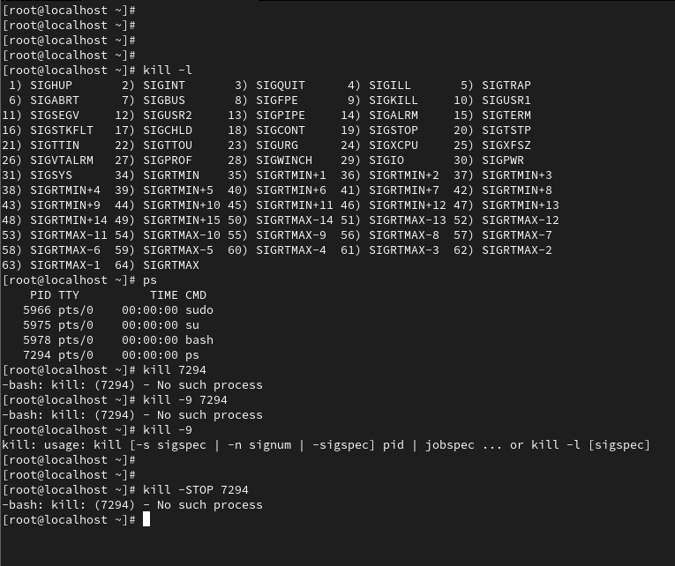
Answer:

- The kill command in Linux sends signals to processes, usually to terminate unresponsive applications using their Process ID (PID).
- When you write the kill -l in cli it displays all the signals.
- Find the process ID with the help of ps.
- After that write kill and enter the PID in this case it is (7294).
- It shows No such process.
- With the help of kill -9 we can terminate the PID forcefully.
- If we want to stop the ps we can write the kill -STOP PID.
- Use top or htop to monitor system resources and processes.

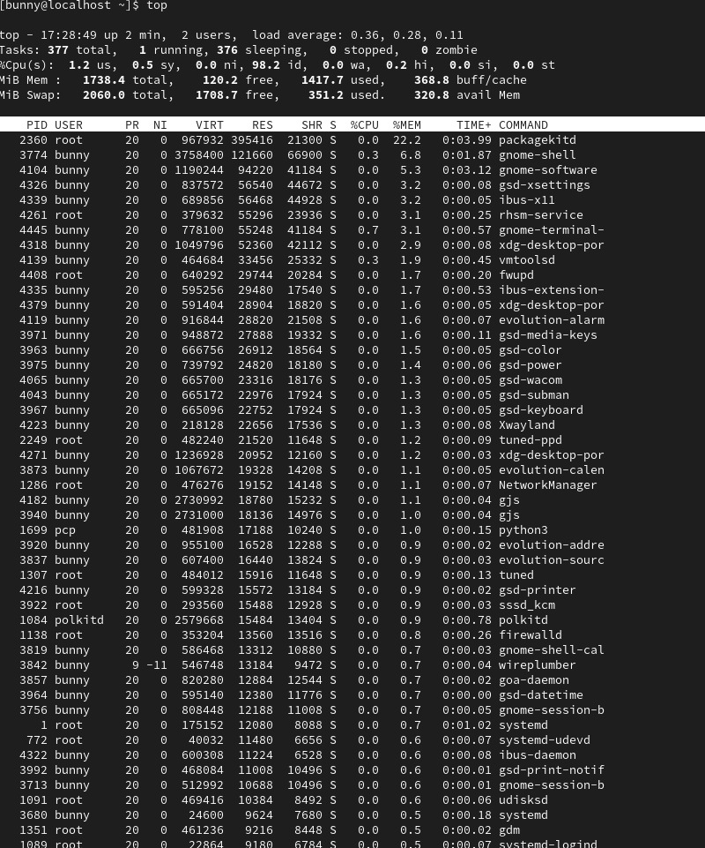
Answer:

- The top command is a real-time system monitoring utility available on Linux systems. It presents a continuously updated view of running processes along with overall system resource usage such as CPU load, memory consumption, and system uptime.
        - Displays a live list of running processes with resource consumption details
        - Shows overall CPU usage, memory usage, and load averages
        - Allows interactive process management from the terminal
        - Updates system statistics continuously without restarting the command
- When you write top -u <username>, it displays the real-time system monitoring information for processes owned by that user only on a Linux system.

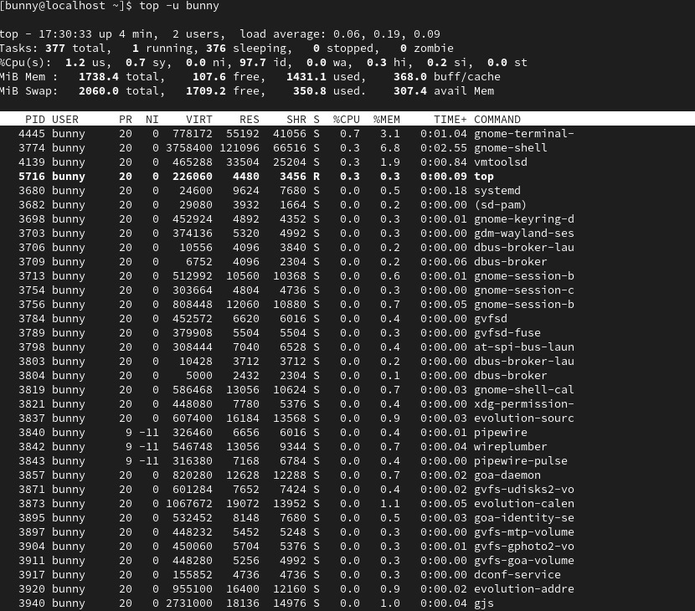

- htop command in Linux system is a command line utility that allows the user to interactively monitor the system’s vital resources or server’s processes in real-time. htop is a newer program compared to top command, and it offers many improvements over top command. htop supports mouse operation, uses color in its output, and gives visual indications about processor, memory, and swap usage. htop also prints full command lines for processes and allows one to scroll down vertically and horizontally for processes and command lines respectively.

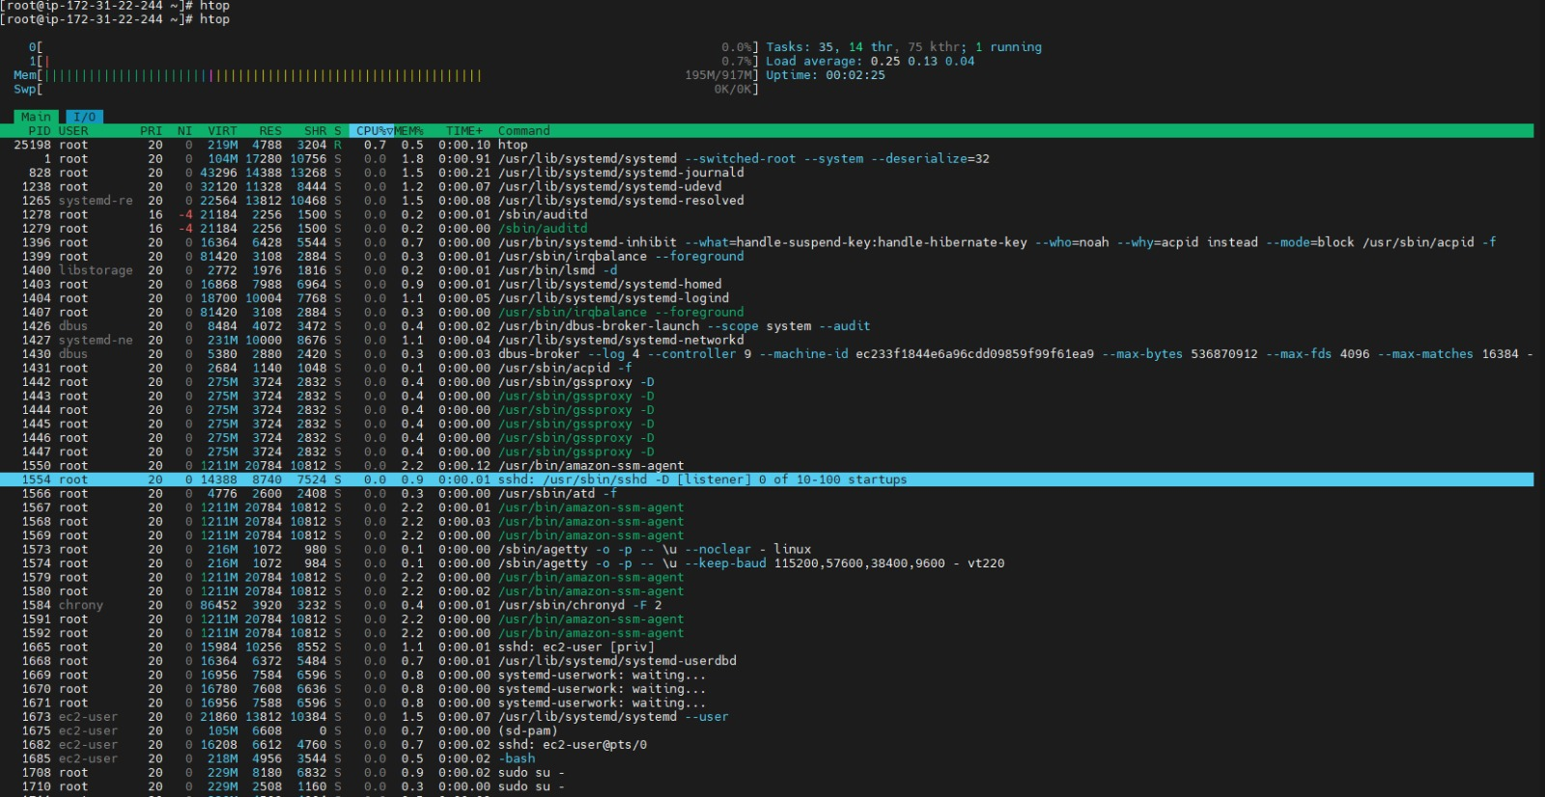

- Configure one of your lab COMPUTERS to boot to the CLI using systemd, and reboot
to confirm that you were successful.

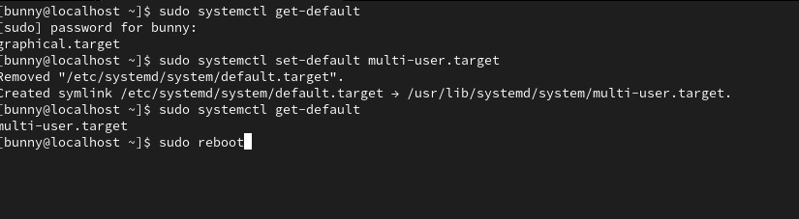
Answer:

1. Check current default target
- sudo systemctl get-default
- Output: graphical.target

This means the system is currently set to boot into GUI (desktop mode).

2. Change default to multi-user (CLI mode)
  - sudo systemctl set-default multi-user.target
  - Output: Removed "/etc/systemd/system/default.target".Created symlink /etc/systemd/system/default.target → /usr/lib/systemd/system/multi-user.target.

  - What happened here:

  - The old default target link (pointing to graphical.target) was removed.

  - A new symbolic link was created.

  - Now default.target points to multi-user.target.

This tells systemd to boot into non-graphical (text/CLI) mode by default.

3. Verify the changes
          - sudo systemctl get-default
          - Output: multi-user.target
Confirmation that the default boot target is now multi-user mode.
4. Reboot the system
      - sudo reboot
After reboot:
        - The system will boot into command-line mode only
- No graphical desktop environment will start automatically
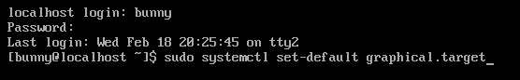
5.If you want to return to GUI mode later
      - sudo systemctl set-default graphical.target
      - sudo reboot

